Hamamatsu Photonics’ Newest Compact, High-Resolution Mini-spectrometers for UV to NIR Spectroscopy
_____________________________________________________________________________________________________
News provided by: Share this article:
Hamamatsu Photonics Europe  
October 15, 2025
Contact us
_____________________________________________________________________________________________________
  - Highly versatile mini-spectrometer ideal for modern spectroscopy
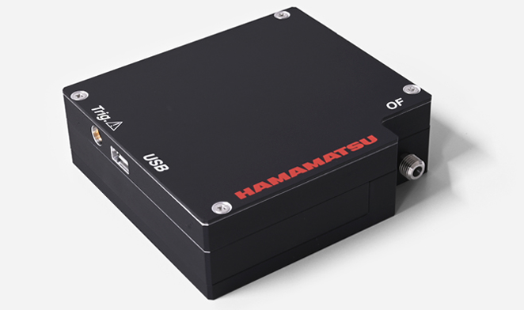
Hamamatsu Photonics launches the WS Series Mini-Spectrometers, a highly versatile new addition to the company's spectrometer lineup. Designed for effective performance in diverse scenarios, these advanced mini-spectrometers deliver exceptional and customizable spectral coverage and resolution in a compact, lightweight enclosure.

The WS Series encompasses two models. The C16449MA-01 provides a broad spectral response range from UV to NIR (190 to 1100 nm), while the C16449MA-02 is optimized for high spectral resolution with a tailored range suited for advanced analytical applications (200 to 600 nm). Both models incorporate a reflective grating optical system paired with a high-sensitivity CMOS sensor, ensuring high performance equivalent to that of traditional CCDs.

Key Features of the WS Series Mini Spectrometers:

- Wide Spectral Response Range: The C16449MA-01 model is versatile for materials analysis, quality control, and scientific research.
- High Spectral Resolution: The C16449MA-02 is tailored for applications like Laser-Induced Breakdown Spectroscopy (LIBS), offering a spectral resolution of 0.45 nm for precise material characterization.
- Compact Design: Measuring just 80 × 75 × 25 mm, the C16449MA series of mini-spectrometers can be easily integrated into various systems without requiring an external power supply, thanks to USB bus powering.
- Flexible Customization: The reflective grating design allows the WS Series to be custom-tailored to customer requirements. Spectral response range and resolution can be optimized for specific applications.

Applications

These spectrometers are exceptionally versatile, making them suitable for R&D, engineers, and industrial professionals needing:
- Film Thickness Measurement: Delivering consistent quality control in manufacturing and R&D for coatings and thin films.
- LIBS (laser-induced breakdown spectroscopy) Analysis: Providing detailed material characterization through high-resolution spectral data.
- Color Measurement: Ensuring accurate color assessment in product development and quality control environments.
- Gas Analysis: Supporting environmental monitoring and industrial settings with high-precision gas detection and characterization.

In addition, Hamamatsu Photonics offers free evaluation software with functions for setting measurement conditions, acquiring and saving data, and drawing graphs. The DLL function specifications are disclosed, allowing users to create their own, original measurement software programs. The company also offers integration support as part of its service.

For more information on the new WS Series, please visit the product webpage or email: marcom@hamamatsu.eu.

Customers looking for customization support should email info@hamamatsu.eu or contact Hamamatsu Photonics online.

------ENDS----

____________________
About Us
Hamamatsu Photonics is a leading provider of cutting-edge photonics technology and products. With 70 years of experience, the company delivers advanced solutions to customers across a wide range of industries, including medical, scientific research, industrial, and telecommunications. Hamamatsu Photonics offers a comprehensive range of products, such as imaging sensors, light sources, and optical systems, designed to meet customers’ unique needs. View their full range of spectrometers here.
www.hamamatsu.com

_____________________________________________________________________________________________________
Keywords: Spectroscopy, spectrometry, Film Thickness Measurement, LIBS analysis, laser-induced breakdown spectroscopy), Raman Spectroscopy, gas analysis, color measurement, high sensitivity mini-spectrometer | Contact us
Market: Academic research, Research & Development, Inspection, LIBS Analysis, Gas Sensing, Quality Control, Industrial
_____________________________________________________________________________________________________

