Phenomenex to Showcase Advanced Separation and Sample Preparation Innovations at Analytica 2026

Booth A3.302C | March 24–27, 2026 | Messe München, Germany


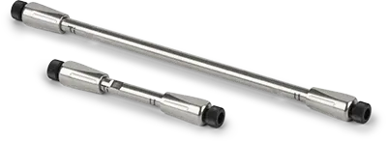
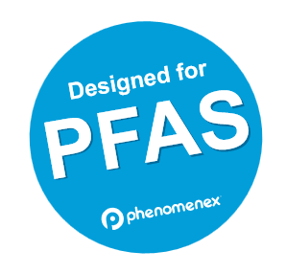
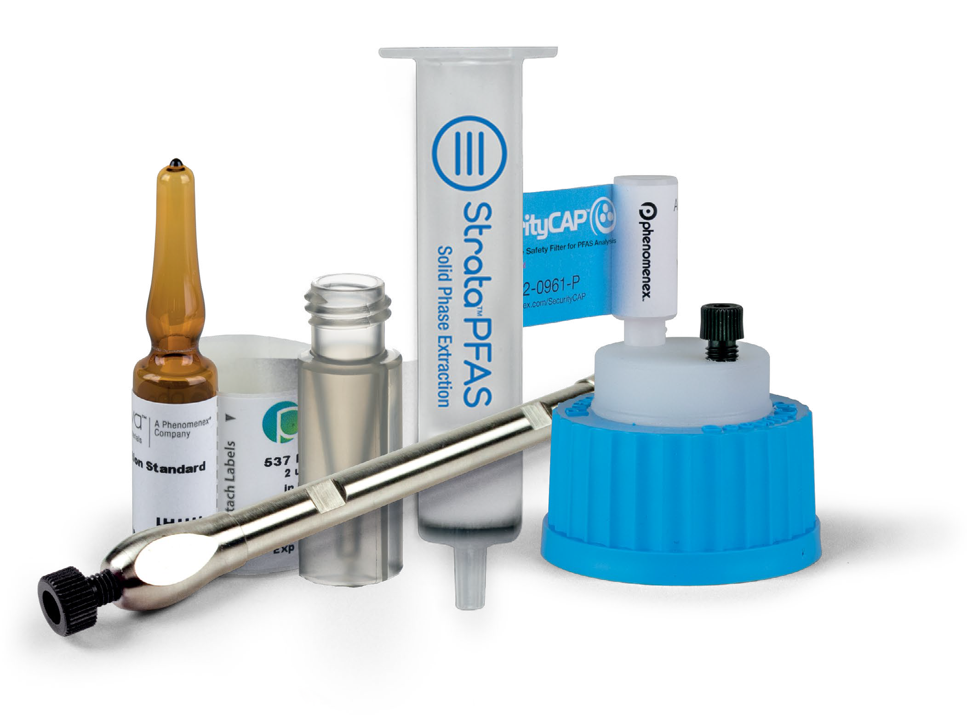
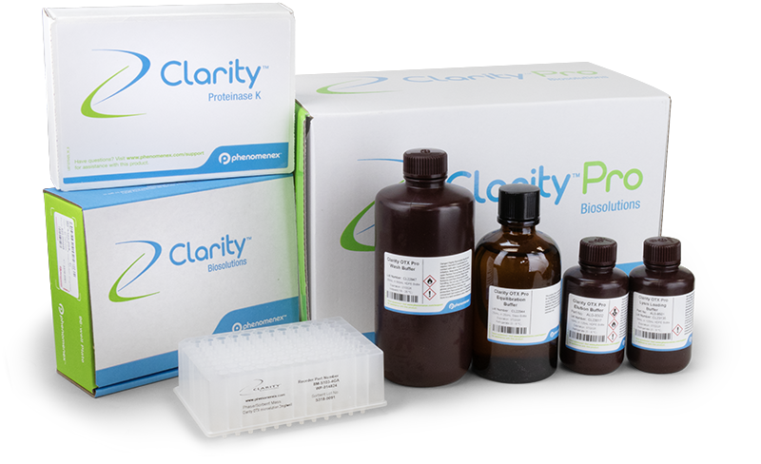

March 6th, 2026
TORRANCE, CA, - Phenomenex, Inc., a global leader in separation science, announces its participation at Analytica 2026, the world’s leading trade fair for laboratory technology, analysis, and biotechnology, taking place in Munich, Germany. Attendees are invited to explore Phenomenex’s latest innovations designed to address today’s most demanding analytical challenges in biologics characterization, oligonucleotide bioanalysis, and PFAS testing workflows:
- Biozen dSEC-1 size exclusion chromatography (SEC) columns, engineered for high resolution aggregate analysis of peptides and mid-sized biologics (1–50 kDa). Designed to support modern biotherapeutic development, Biozen dSEC-1 enables faster analyses, improved peak symmetry, and extended column lifetime, empowering scientists to confidently characterize aggregates, monomers, and closely related species in peptide therapeutics.
- Clarity OTX Pro, a next generation solid phase extraction (SPE) kit designed to standardize and simplify oligonucleotide and oligo conjugate extraction for LC-MS/MS bioanalysis. Purpose built for modern oligonucleotide therapeutics, Clarity OTX Pro is designed to overcome common challenges such as day-to-day variability and extensive method optimization.
- Designed for PFAS portfolio, a comprehensive suite of QC tested and PFAS verified consumables engineered to reduce background contamination and false positives in trace level PFAS analysis. As PFAS regulations continue to evolve globally, the Designed for PFAS portfolio empowers laboratories to maintain data integrity, meet compliance requirements, and streamline PFAS workflows with confidence.
Connect with Phenomenex at Analytica 2026!
Analytica 2026 brings together more than 1,000 exhibitors and 35,000 laboratory professionals to explore the latest developments in chromatography, biotechnology, and laboratory analysis. Phenomenex’s presence reflects its continued commitment to delivering innovative, application‑driven solutions that help scientists advance research, ensure data quality, and improve human and environmental health.
About Phenomenex
Phenomenex is a global technology leader committed to developing novel analytical chemistry solutions that solve the separation and purification challenges of researchers in academic, pharmaceutical, biotech, environmental, clinical research, government, and industrial laboratories. From drug discovery and pharmaceutical development to food safety and environmental analysis, Phenomenex chromatography solutions accelerate science and help researchers improve human health and well-being. Phenomenex is an operating company within the Life Sciences group of Danaher Corporation.

For more information, please visit www.phenomenex.com and follow the company's blog at www.scienceunfiltered.com

Let’s connect: LinkedIn, Twitter, Facebook, Instagram and YouTube
Contact Information: Jannette Avila | Brand and Public Relations | jannettea@phenomenex.com

