SCHNEEBERGER GmbH April 2024
LINEAR TECHNOLOGY

Grafenau 12
D-75339 Hoefen / Enz
Deutschland

Phone +49 (0)7081 / 782- 0
Fax +49 (0)7081 / 782-124
E-Mail info-d@schneeberger.com
Internet http://www.schneeberger.com

Contact:
Peter Schoenbach
Vice President

peter.schoenbach@schneeberger.com

Analytica 2024

SCHNEEBERGER presents the new high-performance cages type KCS and KCN

SCHNEEBERGER presents its new high-performance cages KCS and KCN, derived from the current KBN and KBS cages for crossed roller guides.
These cutting-edge cages boast increased load capacity and rigidity while maintaining full compatibility and 1:1 interchangeability with the KBN and KBS cages.

With minimized roller spacing and optimized roller dimensions, the new cage carries 25% more load on the same cage length their predecessors, or they can be constructed significantly shorter while maintaining the same roller count. This enables rail length and weight to be saved with the same stroke.

The new KCS and KBS cages have passed our endurance tests with flying colors.
They’ve endured maximum accelerations of 300 m/s² (with cage forced control) and 50 m/s² (without cage forced control), as well as a speed of 1 m/s, without any problems.

Crafted from premium materials, the new KCS/KCN cages ensure prolonged durability and reliability even in challenging conditions. Engineered to operate within a temperature range of -40°C to +80°C, they seamlessly adapt to both cleanroom environments and vacuum conditions up to 10-7 mbar without modification. Tailored for demanding applications across diverse industries, their exceptional characteristics make them particularly suited for highly dynamic and space-constrained environments.

With these innovations, SCHNEEBERGER reaffirms its commitment to pioneering innovation and quality, ensuring it meets the growing demands of its global customer base.

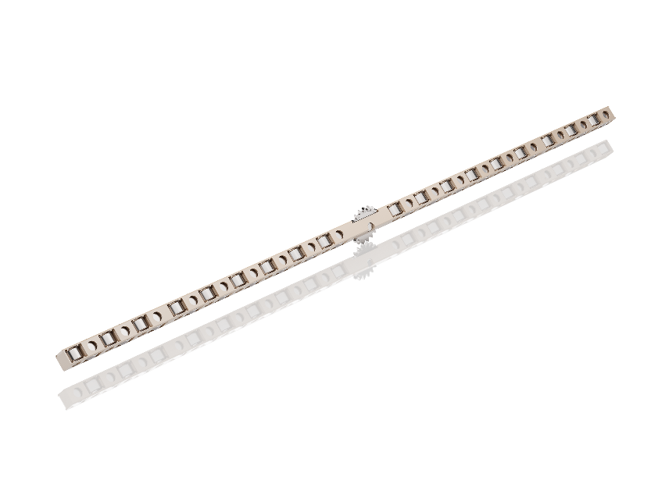
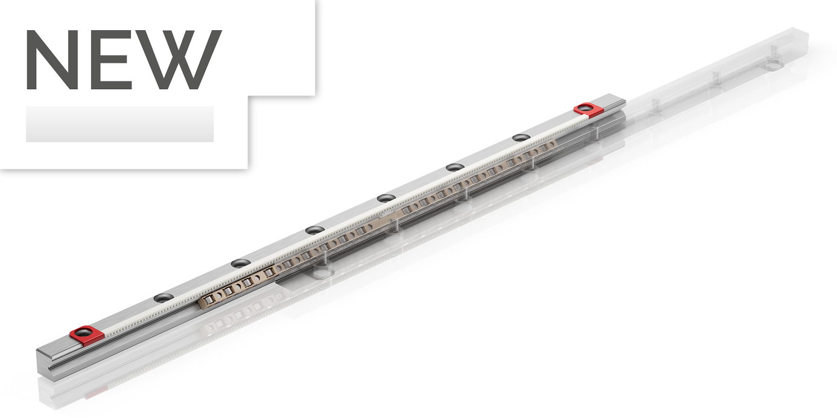

Fig.: High Performance cage KCS for linear bearings

