SCHNEEBERGER GmbH April 2024
LINEAR TECHNOLOGY

Grafenau
D-75339 Hoefen / Enz
Deutschland

Phone +49 (0)7081 / 782- 0
Fax +49 (0)7081 / 782-124
E-Mail info-d@schneeberger.com
Internet http://www. schneeberger.com

Contact:
Peter Schoenbach
Vice President

peter.schoenbach@schneeberger.com

Analytica 2024

MINISCALE Plus
Miniature guide with integrated measuring system - "all in one".
MINISCALE PLUS is based on the proven MINIRAIL miniature guide. Accordingly, the guide specifications of MINIRAIL apply to MINISCALE PLUS.
The range comprises eight rail widths that can be combined with up to four carriage sizes.
MINISCALE PLUS is consistently accurate and reliable. The measurement is made directly during the working process, which significantly reduces the Abbe error.
The MINIRAIL profiled rail guides with the MINISCALE PLUS integrated measuring system impresses with their precision and robustness. This product was developed for high speeds and accelerations in the working process. Its applications can be found in various high-tech areas.

Sizes (rail width in mm) 5, 7, 9, 12, 15 and 14, 18, 24, 42
Resolution 0,1 µm
Accuracy up to 1000 mm = +/- 5 μm
Repeatability Unidirectional = +/- 0,1 μm, Bidirectional = +/- 0,2 μm
Length of measuring scale Max. 1000 mm
Speed 5 m/s analog, 3,2 m/s digital
Output signal Analog: 1 Vpp (at 120 Ω).
Digital: TTL according to RS 422 standard

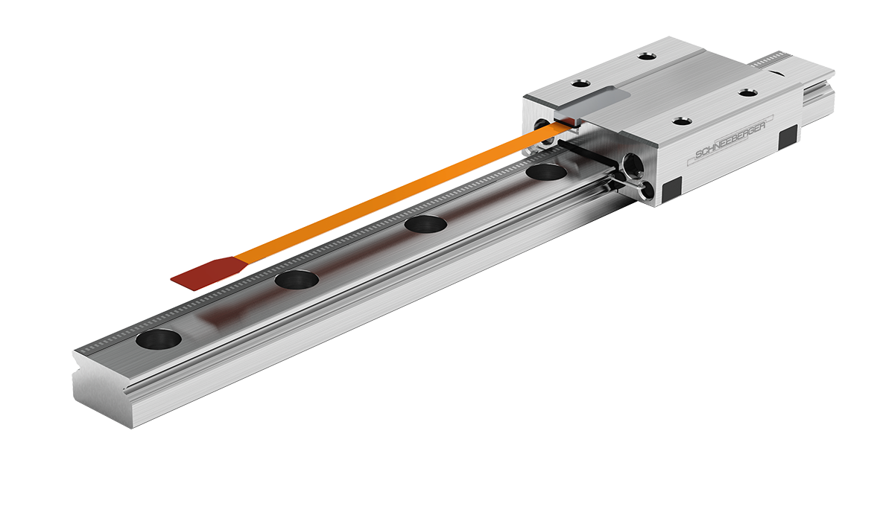

Fig.: MINISCALE Plus

