SCHNEEBERGER GmbH April 2024
LINEAR TECHNOLOGY

Grafenau
D-75339 Hoefen / Enz
Deutschland

Phone +49 (0)7081 / 782- 0
Fax +49 (0)7081 / 782-124
E-Mail info-d@schneeberger.com
Internet http://www.schneeberger.com

Contact:
Peter Schoenbach
Vice President

peter.schoenbach@schneeberger.com

Analytica 2024

HIGHLY PRECISE GROUND MINIATURE BALL SCREW from diameter 3 mm - 40 mm

Miniature ball screws are preferably used in semiconductor technology, optics, medical technology, biotechnology, analytics and measurement technology.

For this purpose, we offer a wide standard range of high-precision ground miniature ball screws.

The standard product range includes thread lengths up to max. 1000 mm and diameters from 4 - 40 mm. Pitches from 0,5 mm to 10 mm are possible.
All ball screws are produced due to IT tolerance classes 1 to 10 according to DIN 69051.

We use the following materials as standard:
Ball screw: Cf53 - ball track hardened to 60 +/-2 HRC.
Ball screw nut: 100Cr6 - hardened to 60 +/-2 HRC.

Of course, we also produce stainless ball screws from the following materials

Ball screw: 1.4112 - ball track hardened to 60 +/-2 HRC.
Ball screw nut: 1.4034 - hardened to 60 +/-2 HRC.

We also manufacture ball screws that differ from our standard in every respect, such as special nut shapes, deviating pitches and diameters, or ball screws made of special materials.
We define this success with the highest benefit in terms of technology, cost and production - always aware that the quality of the ball screw significantly influences the quality of the final product.
For price and delivery time information a simple drawing or sketch is sufficient.
Give us the challenge!

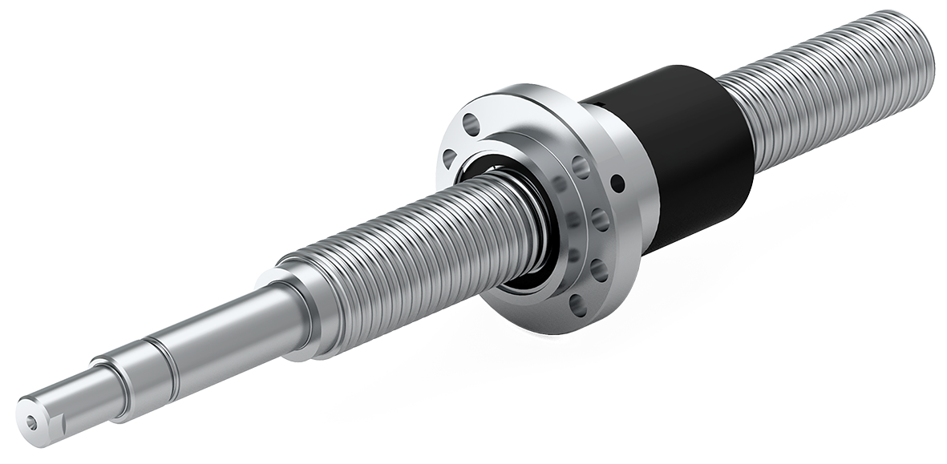

Fig.: Ball Screw

