SCHNEEBERGER GmbH April 2024
LINEAR TECHNOLOGY

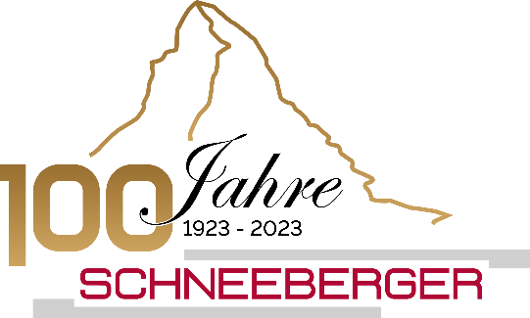
Grafenau
D-75339 Hoefen / Enz
Deutschland

Phone +49 (0)7081 / 782- 0
Fax +49 (0)7081 / 782-124
E-Mail info-d@schneeberger.com
Internet http://www.schneeberger.com

Contact:
Peter Schoenbach
Vice President

peter.schoenbach@schneeberger.com

Analytica 2024

Linear guides type R, RN, RNG
Cross roller guides from SCHNEEBERGER optionally with cage control system

The R linear guide was introduced by SCHNEEBERGER as the first standardized rolling guide worldwide and is now considered the industry standard.
Highly loadable guidance concepts with rollers or balls can be realized with the smallest installation dimensions. The high performance of the comparatively small guide cross-sections results in unrivaled cost-effectiveness in many applications.
Our standard product range includes sizes 1, 2, 3, 4, 6, 9 and 12 in lengths from 20 mm up to 1500 mm.
The RN and RNG type cross roller guides are the optimization of the R guide.
FORMULA-S system is based on the dimensions of the proven linear guides of types RN and RNG. Due to its sophisticated design, it can be easily integrated into your existing construction. FORMULA-S works in any mounting position, regardless of the preload of the guide.
The FORMULA-S integrated cage constraint control fully meets the requirements in terms of productivity and economy. It is very robust, has a simple design and consists of only a few components.
The main advantages of the cage constraint control system are its trouble-free operation, which increases productivity. The high accelerations enable fast strokes and consequently reduce cycle times. No readjustment of the cage is needed, not even in vertical installation. In addition, the shape and position tolerances of the surrounding structure or temperature differences do not lead to cage wandering and the service life is increased significantly.

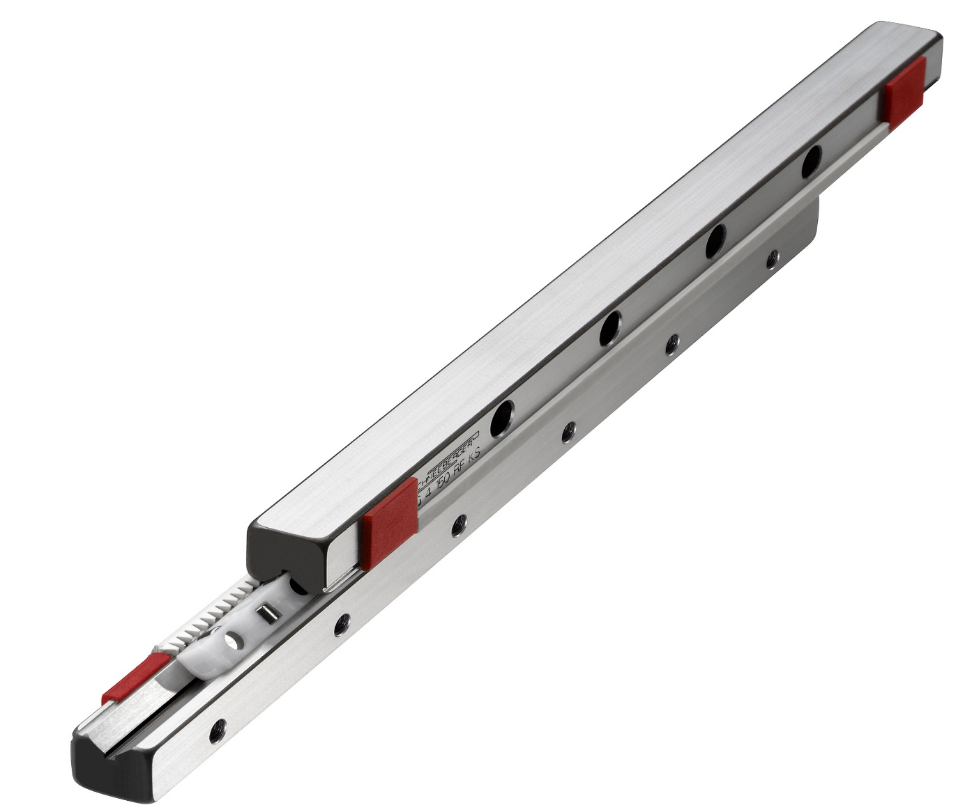

Fig.: Cross roller guides type R with integrated cage control system

